USING AERIAL IMAGE ANALYSES AS A TOOL FOR TOPSOIL, SOIL AND SUBSTRATE MAPPING IN VINEYARDS (BURGUNDY, FRANCE)
L’ANALYSE D’IMAGES : UN OUTIL DE CARTOGRAPHIE DE L’ETAT DE SURFACE DU SOL, DU SOL ET DU SOUS-SOL EN CONTEXTE VITICOLE (BOURGOGNE, FRANCE)
Emmanuel CHEVIGNY^{1*}, Amélie QUIQUEREZ¹, Christophe PETIT², Pierre CURMI³, Françoise VANNIER-PETIT⁴, Christian CAMERLYNCK⁵
¹ UMR CNRS 6298 ARTeHIS, University of Burgundy, France
² UMR 7041 ArScAn, University of Paris 1, France
³ AgroSup, UMR 1347 Agroécologie, BP 86510, F-21000 Dijon, France
⁴ Geological engineer, La Rente Neuve, F-21160, Flavignerot, France
⁵ UMR CNRS 7619 SISYPHE,University Pierre-et-Marie Curie Paris IV, France
* Corresp. author: CHEVIGNY, Email: Emmanuel.Chevigny@u-bourgogne.fr
SUMMARY
The Burgundy vineyards have been recognized for their high diversity of terroirs, controlled by complex interactions between natural processes, historical parameters and soil management practices. The relationships between these factors control the typicity of each wine. A better understanding of how terroirs have been defined is necessary for a sustainable, rational management of vineyard soils.
The objectives of the study are (i) to identify the terroir variability in the Burgundy vineyards (France) at hillslope scale and (ii) to discriminate the role of natural (soil, substrate, slope morphology) and anthropogenic factors (management practices) in controlling the terroir diversity. Our approach unites aerial image classification acquired at very high spatial resolution (VHRS) with local soil sampling. VHSR aerial image processing allows precise mapping of the spatial distribution of soil surfaces; soil sampling defines soil typology by physical and chemical characteristics. In addition, we have performed 2D electrical resistivity profiles to define the underlying geological substrate. Our results show that soil types are mainly controlled by the geological substrate and topography. The diversity of management practices may contribute to a soil diversification for a defined geological substrate.
RÉSUMÉ
Le vignoble bourguignon est reconnu pour sa grande diversité de terroirs, contrôlée par des interactions complexes entre des facteurs naturels (géologie, sol, topographie) et des facteurs anthropiques (pratiques culturales historiques et actuelles). L’interaction de ces facteurs entre eux participe à la caractérisation de la typicité des vins bourguignons. C’est pourquoi, une meilleure compréhension du fonctionnement des terroirs est nécessaire pour une gestion rationnelle et durable des sols viticoles.
Les objectifs de cette étude sont (i) d’identifier la variabilité des terroirs dans le vignoble bourguignon à l’échelle spatial du versant et (ii) de mettre en évidence les facteurs naturels et anthropiques qui contrôlent la diversité des terroirs. Nous avons développé une méthode qui se base l’analyse d’image à Très Haute Résolution Spatiale (THRS) dans le domaine du visible combiné à des prélèvements de sols pour caractériser l’état de surface du sol et réaliser un cartographie des sols. Pour comprendre la distribution spatiale des sols sur le versant nous avons acquis un profil en 2D de résistivité électrique du sous-sol pour caractériser la géologie du versant. Les résultats montrent en premier lieu que la nature géologique détermine la variabilité spatiale des types de sol ; en second lieu, que les facteurs anthropiques peuvent conduire à une différenciation pédologique pour un même substrat.
Keywords: Vineyard soils, terroir diversity, Very High Spatial Resolution (VHSR) aerial image, electrical resistivity, geological substrate.
Mots Clés : Sols viticoles, diversité des terroirs, imagerie à Très Haute Résolution Spatiale (THRS), résistivité électrique, substrat géologique.
INTRODUCTION
The Burgundy vineyards display a high diversity of terroirs, resulting from complex interactions between natural factors (geological substrate, soil, topography) and anthropogenic factors (historical and present-day management practices). Even if we cannot identify the role of each factor on the quality of wine production, we know that the combination of all them define wine typicity. The study of vineyard soils leads to a better understanding of the diversity of terroirs and of their spatial distribution. Moreover, the knowledge of the spatial variability of the physical environment is a part of a sustainable and economic approach of precision viticulture.
This work aims at improving our understanding of terroir from the mapping of soil surface characteristics. Our method combines VHSR images analysis permitting soil surface heterogeneities identification at a centimetre spatial scale (Wassenaar et al., 2005; Corbane et al., 2008) and local soil sampling. For each soil surface class mapped at the hillslope scale, several auger holes are performed, allowing soil type identification. These surface soil characterisations were combined to Electrical Resistivity Tomography (ERT) surveys to delineate the geological substrates distribution on the hillslope.
In this work, we first describe the topsoil characterisation from aerial image classification and local soil descriptions by physical and chemical analyses. We then present the ERT profiles, to finally discuss the role of geological substrate and management practices on the soils distribution.
MATERIALS AND METHODS
Study area
The study area is located on the hillslopes of the Aloxe-Corton vineyards, in the Côte de Beaune (Burgundy, France). The hillslopes shaped by the Bressan rifting, form the eastern border of the Burgundy plateau (Rat, 1986). The landscape is characterised by a vine monoculture where the plot limits, i.e. paths, roads and walls form the only discontinuities. The study area extends from the Corton wood downslope to the road D974 that marks the limit of the extension of the vineyards.
Topsoil and soil mapping from Very High Spatial Resolution (VHSR) image processing
VHSR aerial images in the visible domain (0.4-0.7 µm) were acquired in April 2009 by the unmanned helicopter DRELIO (Delacourt et al., 2009) at a centimetre spatial resolution (Figure 1). The flight took place at near solar midday to have constant illumination conditions. The helicopter is equipped with a reflex digital camera Nikon D700 with a 35 mm equivalent focal lens, an automatic piloting system and an onboard GPS giving the geographic position during the flight. Images were acquired at a 70 m flying altitude during early spring, to avoid leaf and plant cover.
Image pre-processing consists in the construction of a mosaic from 100 selected images. The images were first georeferenced using control points from a differential GPS, and then pseudo-orthorectified. The artefacts obstructing soil information (roads, agricultural paths, vinestocks and their shadows) were masked before image analysis. The mosaic was resampled to a 25 cm resolution to reduce computing time while still enabling intra-plot topsoil diversity to be visualised at the hillslope scale. We then classified images to map soil surface using an unsupervised ISODATA method without any a priori knowledge of the number of soil classes or of their spatial distribution.
The obtained map allows distinguishing four soil surface classes. For each class defined by image processing, local soil surface descriptions and soil profiles were performed to characterise the soil types. Eighteen soil surface samples were collected in the 0-10 cm soil layer in the inter-row over a 0.25 m² surface along the hillslope and thirteen auger holes were performed. Complementary data coming from eight soil pits on contiguous plots were also used. On these samples, physical (stoniness, grain-size distribution, matrix colour) chemical (total calcium carbonate, organic carbon, nitrogen and free iron contents) analyses were performed to define the topsoil and soil characteristics.
Geological substrate investigations
We have investigated the geological substrate of the Aloxe-Corton hillslopes using geophysical electrical method. Electrical Resistivity Tomography (ERT) has been widely used to obtain images of the subsurface from the measurement of substrate electrical resistivity. Differences in electrical resistivity may be induced by changes in lithology, (such as limestone, marl or shale) or may indicate a fault occurrence (Loke, 1996-2004). The acquisitions were made with a A Syscal R1+ (IRIS Instruments), using a line of 96 electrodes regularly spaced at 4 m intervals, and using 3012 quadripoles in a Wenner-Schlumberger configuration. To cover all the hillslope, 2 roll-alongs were acquired and merged to produce only one profile. This device allows investigating the geological substrate to a depth of 50 m. The raw data were filtered to delete surface heterogeneities effects on deep layers. Next, an inversion is applied on filtered data, using iteration process with the Res2dinv software (IRIS Instruments), to produce 2D profils.
RESULTS AND DISCUSSION
Figure 2 shows that soil surface class (SSC) types evolve along the hillslope. The SCC1 (red class) located in the upper part of the hill, evolves gradually in the middle of the slope towards SSC2 (yellow class). The downslope area is defined by SSC3 (blue class) and SSC4 (cyan class). This downslope SSC succession is correlated to a downslope decrease of the carbonate and organic matter contents and a downslope evolution of soil colour from brown (SSC1) to reddish-brown (SSC2) to strong brown (SSC3 & 4). Free iron content is low for SSC1, SSC3 and SSC4 and higher for SSC2.
The auger holes and soil pits dug into the different SSCs defined by image processing, allow distinguishing four SSCs, grouped into three soil types. SSC1 and SSC2 are defined as Calcosol developed on Oxfordian marly-limestones for SSC1 and Oxfordian cherty limestones for SSC2. Soil depth varies from 40 to 150 cm. They are characterised by high gravel, high carbonate and high organic contents. They differ mainly by their carbonate content and their texture (silt-loam to clay). Downslope, we suggest that difference in reflectance values between SSC3 and SSC4 reflects two management practices. All the area is covered by tertiary alterites composed of chert clays spreading. On this formation, soils are a deep Luvisol (>160 cm) deposed on Callovo-oxfordian limestones in the middle of the slope. They are characterized by a clay-loam texture, a high stoniness and very low carbonate content. Around the D974, chert clays layer is thinner, soils are Calcosol developed on tertiary marls, characterised by low stoniness and low organic matter content, and a high carbonate and free iron contents, excepted in topsoil surface where carbonate content is null.
The acquisition of a 2D apparent resistivity profile allows mapping changes in lithology along the hillslope (Figure 3). The electrical profile combined with punctual field outcrops allow to propose a geological model of the Corton hillslope that the upper slope is dominated by marl beds alternating with Oxfordian limestones. The middle slope is constituted by Callovian limestones with high resistivity values. These limestones are covered downslope by tertiary alterites (chert clays spreading). In the downslope, tertiary lacustrine marls covering Bathonian limestones extend.
Our results show that each soil surface class defined by image analyses are characterised by their own physico-chemical properties. The use of aerial image in the visible domain allow distinguishing fine differences of textural, mineralogical and agricultural management of the soil surface. This method may be used to identify both abrupt changes (agricultural practices) continuous evolution (related to surface sediment dynamic) and changes of soil composition (related to substrate).
But also, our work shows that the soil distribution in the Aloxe-Corton vineyards evolves according to the “topolithoséquence” model proposed by Mériaux (1981). This model suggests that the soil distribution in the hillslopes depends on geological substratum and topography. The AOC delimitation (Appellation d’Origine Contrôlée) draped on the soil map present on the Figure 4, show that soil is an important factor in terroir diversity. For example the limit between White Grand Cru and Red Grand Cru correspond to the change of lithology between a marly formation to a cherty limestone formation, or the limit between Calcosol and Luvisol in downslope match the change of AOC Grand Cru and AOC Village.
Moreover, our results highlight the impacts of human activities on soil type and soil distribution. Some anthropogenic structures can influence soil diversification. The walls, roads, agricultural paths, are obstacles to sediment transfer on the hillslope and create sedimentation area in downslope of plots, leading to soil diversification (limit between SSC2 and SSC3). This approach highlight changes of agricultural management, as we can see in the downslope (Figure 2). Mapping soil management practices is important and must be take into account in terroir study, because some of these can modify physical soil properties (compaction) or chemical soil properties (amendment, grassing). These modifications resulting from management practices may eventually change the type of soil.
CONCLUSIONS
This research presents a simple, highly efficient approach to map soil surface diversity at a high spatial resolution in Burgundy vineyards. This approach relies on the combination between very high resolution aerial and geophysical data at the hillslope scale and local observations. VHSR aerial image processing establishes a precise mapping of the spatial distribution of soil surfaces. This map associated with soil sampling is an interesting tool to define soil typology by physical and chemical characteristics. Moreover, geophysical investigations allow characterizing geological substratum, which partly control soil distribution. By allowing the visualisation of soil distribution at a very high spatial resolution, this approach offers new insights and possibilities for documenting soil patterns and for exploring and predicting soil evolution through space and time on hillslopes, and so could be used for precision viticulture.
ACKNOWLEDGEMENTS
This work was made possible by the financial support of Burgundy regional council (CRB) and the inter-professional bureau of Burgundy vines (BIVB).
REFERENCES
Corbane C., Raclot D., Jacob F., Albergel J., Andrieux P., 2008. Remote sensing of soil surface characteristics from a multiscale classification approach. Catena, 75, 308-318;
Delacourt C., Allemand P., Jaud M., Grandjean P., Deschamps A., Ammann J., Cuq V., Suanez S., 2009. DRELIO: An Unmanned Helicopter for Imaging Coastal Areas.
Loke M.H., 2004. Tutorial: 2-D and 3-D electrical imaging surveys. Personal notes, 1996-2004, revised the 26th July 2004, 128 p;
Mériaux S., Chrétien J., Vermi P., Leneuf N., 1981. La Côte viticole. Ses sols et ses crus. Bulletin scientifique bourguignon, 34, 17-40;
Rat P., 2006. Guide géologique Bourgogne Morvan. Dunod, 2e édition, 216 p;
Wassenaar T., Andrieux P., Baret F., Robbez-Masson J-M., 2005. Sunlit soil surface extraction from remotely sensed imagery of perennial, discontinuous crop areas the case of Mediterranean vineyards. Catena, 62, 94-110;

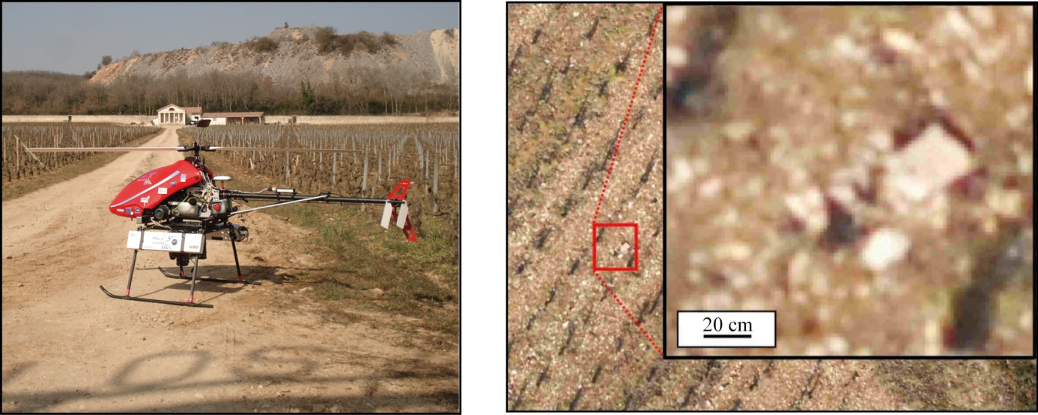
Figure 1 Unmanned helicopter DRELIO equipped with the Nikon D700 digital camera. Example of a Very High Spatial Resolution (VHSR) image with a pixel resolution of about 2 cm.
Figure 1 Drone hélicoptère DRELIO équipé d’un appareil photo numérique Nikon D700. Exemple d’une image à Très Haute Résolution Spatiale (THRS) présentant une résolution spatiale de 2 cm.
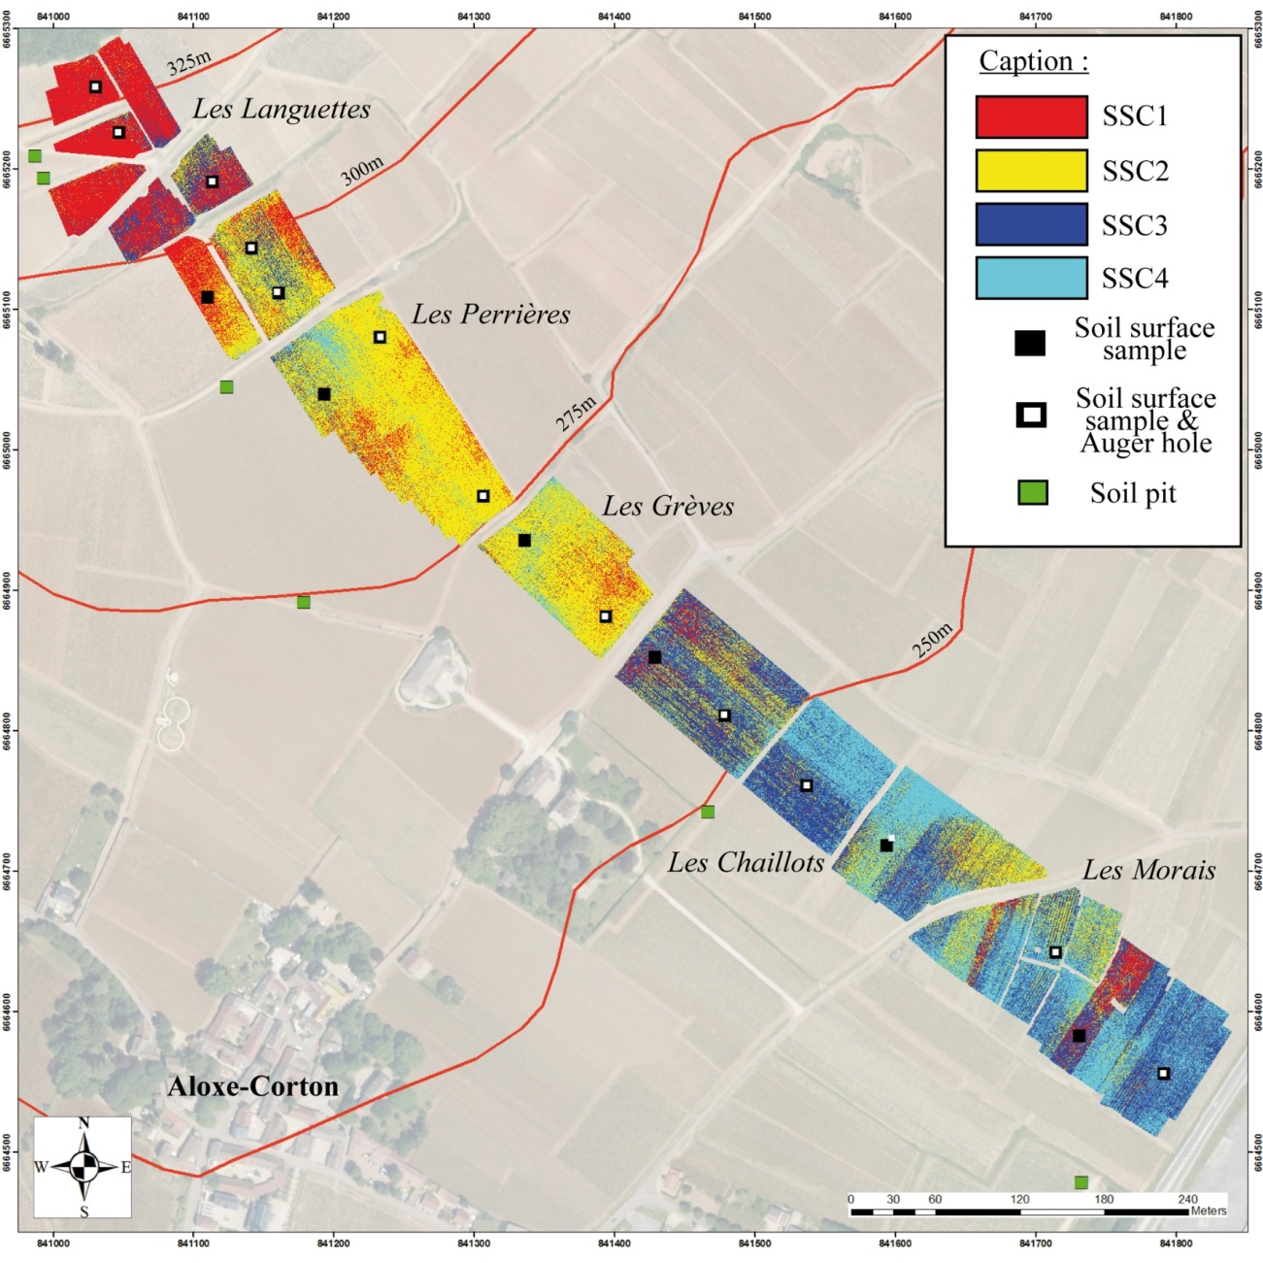
Figure 2 Soil Surface Class (SSC) map for the Aloxe-Corton hillslope. SSC distribution evolves from upslope to downslope.
Figure 2 Cartographie des Etats de Surface du Sol (EDS) du versant d’Aloxe-Corton. La distribution spatiale des EDS évolue d’amont en aval du versant.
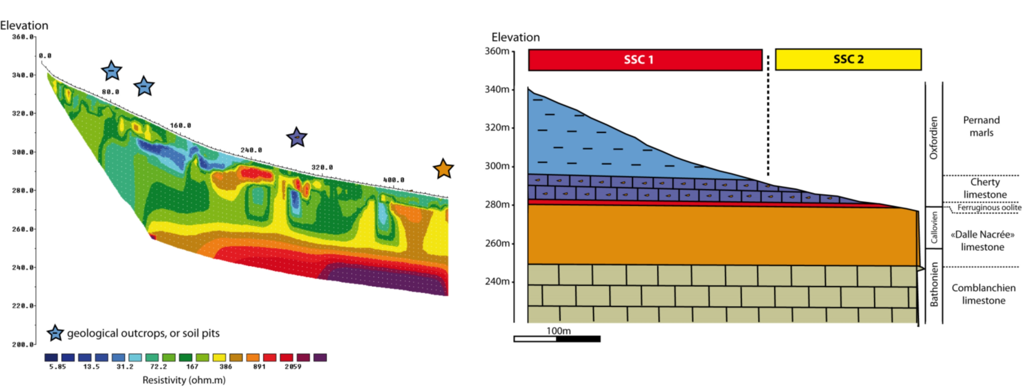
Figure 3 Upper part of the 2D profile of electrical resistivity (on le left) and geological cross section of highlighting lithological control of SSC and soil distribution (on the right).
Figure 3 Partie supérieure du profil de résistivité électrique en 2D (à gauche) et coupe géologique du secteur mettant en évidence le contrôle lithologique sur la distribution spatiale des EDS et des sols (à droite).
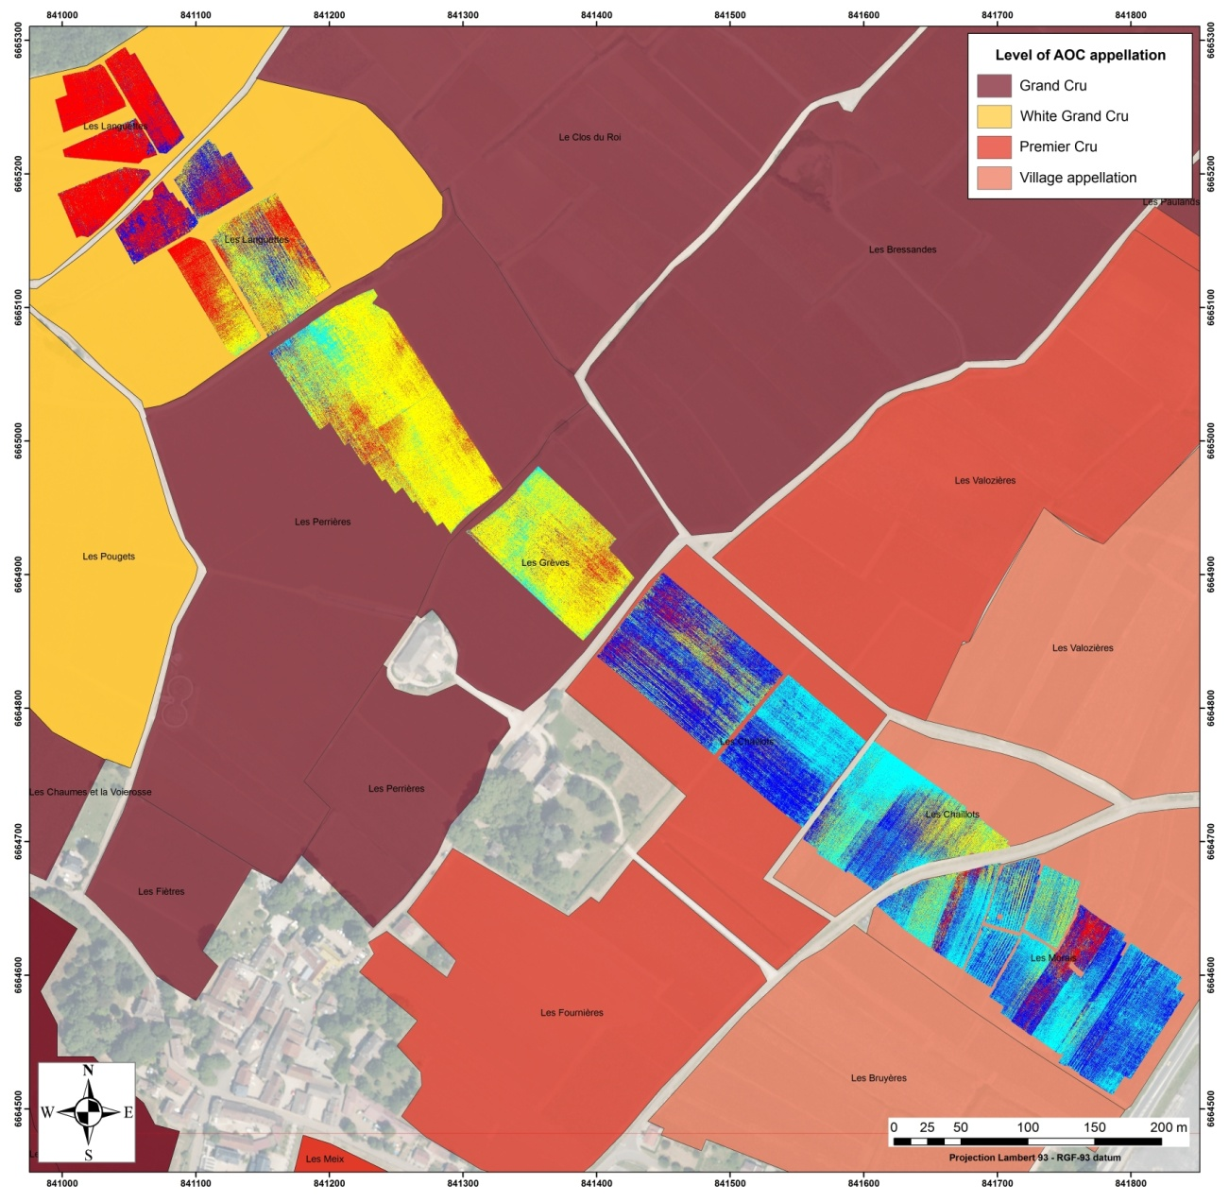
Figure 4 SSC map overlaid on the Appellation d’Origine Controlée (AOC) classification map.
Figure 4 Cartographie des EDS drapée sur la carte des niveaux d’Appellation d’Origine Controlée.

