BURGUNDY RED WINES’ REPRESENTATIONS FOR THOSE INVOLVED IN THE SECTOR

MoniaSAIDIªAurélie LOISON^{b}ChristineFANT^{c} Yves LE FUR^{b}Georges GIRAUDª

ª Département Sciences Humaines et Sociales ; UMR CESAER INRA- AgroSup Dijon, 26 Boulevard Docteur Petitjean, 21000 Dijon, France
^{b} Centre des Sciences du Goût et de l’Alimentation ; UMR 6265 CNRS, UMR 1324 INRA-Université de Bourgogne, 21000 Dijon, France.
^{c} Département Sciences de l’Ingénieur et des Procédés, AgroSup Dijon, 26 Boulevard Docteur Petitjean, 21000 Dijon. France.

E-mail :monia.saidi@dijon.inra.fr

Keywords : red wine; sensory analysis; exemplarity; representation; wine sector

- INTRODUCTION

Do the two principal parties concerned with the wine-producing sector share the same representation of what the Burgundy red wine is?. To answer this question, two different parties in the wine producing sector were surveyed: those involved in production (wine growers, oenologists, technicians) and those with the finished product (restaurant owners, sommeliers, wine merchants). Their exemplarity judgments of Burgundy red wines allowed to estimate their degree of agreement or disagreement in visual evaluation and in smell and taste evaluation.

- METERIELS AND METHODS

Forty Burgundy red wines of basic and medium range, pinot noir, vintage 2010, illustrating as far as possible the diversity of the supply from diverse vine culture and oenological practices were selected for this study and presented in two blocks of 20 wines.

Forty professionals belonging to both parties participated in the study. They had no preliminary training in the test of categorization. To estimate the 40 wines, each subject had to participate in two sessions (to evaluate a block of wine per session). They were asked to judge the level of exemplarity of 40 wines, at first visually, then independently, based on aroma and taste. The holistic sensory approach here is based of the method worked out by Ballester et al. [1], used then by several authors [ 2-3-4 ].

- RESULTS AND DISCUSSION

The individual exemplarity scores of the forty professionals were studied for each evaluation with a three-way (subject, type, wine ) analysis of variance (ANOVA). The results of this analysis are shown in table 1. The treatment was done with Statistica (version 10, Statsoft Inc., Tulsa, OK, USA).
The factor type gives the profession, either in vine growing or wine dealing. The subject factor is subordinated to the factor type and considered here as a random factor. Another factor is also considered in this model: the factor order which shows order of presentation of both blocks of 20 wines, interacting with all the fixed factors. It is necessary to underline that the effect of order of presentation of the blocks of wines was checked at the same time for the visual evaluation and for the smell and taste evaluation.
Table 1 : Results of three-way ANOVA, visual evaluation, smell and taste evaluation

 | Visual evaluation |  |  |  | Smell and taste evaluation
 | DDL | MC | F | p | DDL | MC | F | p
SUBJET(TYPE*ORDER) | 36 | 32,15 | 13,53 | 0,00 | 36 | 33,70 | 7,20 | 0,00
TYPE | 1 | 1,19 | 0,04 | 0,85 | 1 | 16,35 | 0,49 | 0,49
ORDER | 1 | 53,28 | 1,66 | 0,21 | 1 | 0,11 | 0,00 | 0,96
WINE | 39 | 97,93 | 41,21 | 0,00 | 39 | 31,21 | 6,66 | 0,00
TYPE*ORDER | 1 | 0,15 | 0,00 | 0,95 | 1 | 40,09 | 1,19 | 0,28
TYPE*WINE | 39 | 4,55 | 1,92 | 0,00 | 39 | 6,89 | 1,47 | 0,03
ORDER*WINE | 39 | 1,94 | 0,82 | 0,78 | 39 | 5,52 | 1,18 | 0,21
TYPE*ORDER*WINE | 39 | 2,10 | 0,88 | 0,67 | 39 | 7,40 | 1,58 | 0,01
Error | 1404 | 2,38 |  |  | 1404 | 4,68

The results of the ANOVA show that whatever the mode of evaluation and the status of the professional (type) within the sector, there is a significant difference of scoring between the subjects. This result consolidates the idea that there is an interpersonal variability. On the other hand, there is no interaction order*wine. Whether the blocks of wines are presented in the first or second session does not influence the wine score.

The results of the ANOVA on both, visual and smell and taste evaluations, highlight a significant interaction between the status of the professional in the sector and the wine. The nature of their work has an influence on their representation of Burgundy red wines: wines were estimated differently according to the status of professionals. So, because of the significance of the interaction type*wine, it is impossible to study the effects of the factor type and of the factor wine separately, in this case.

To display the degree of convergence or difference between the forty professionals and to understand the coherence of the measure of exemplarity, two ACP were doneby means of the software Statistica. It was completed by the calculation of the W of kendall coefficient [5].

The first ACP is relative to the visual evaluation. The projection of the subjects on the first two main components is presented in figure 1

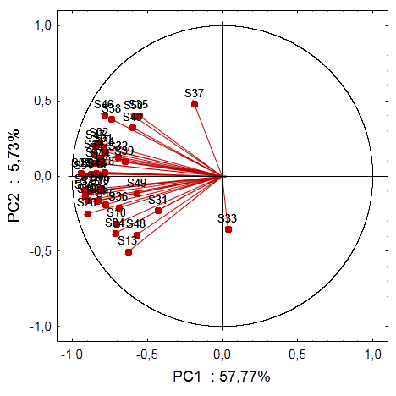
Figure 1 : PCA Correlation circles for exemplarity scores: Visual evaluation

The principal component explains 63.5% of the total variance. Altogether, we notice a good representation of the various subjects, with the exception of subjects S33 and S37. The graph also highlights the unidirectional character of vectors and so underlines the clear convergence of the sensory answers brought by the subjects. There also, only subjects S33 and S37 distinguish themselves. Without ambiguity, it is possible to deduce from this that the great majority of 40 subjects share the same representations of the color of a good (or conversely of a bad) example of Burgundy pinot noir wine. Beyond these descriptive statistics, the degree of convergence of the subjects was calculated by the determination of the coefficient of concordance W of Kendall. In the case of visual evaluation, this coefficient is equal to 0.48. This significant coefficient (p < 0.0001) confirms the concordance of subjects. The second ACP concerns the smell and taste evaluation. Figure 2 presents the projection of the subjects on the first two main components.

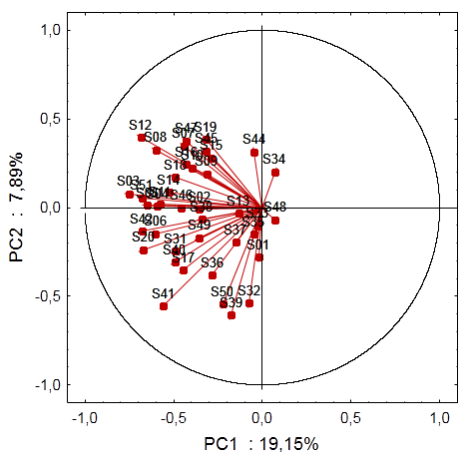
Figure 2: PCA Correlation circles for exemplarity scores: smell and taste evaluation

In this case, the main plan explains only 27% of the total variance. Contrary to figure 1, most of the subjects are poorly represented - they are almost all in the same direction, on the same side of the axis1. The 40 subjects are far from being unanimous but their representation of the smell and taste universe of a good (and conversely of a bad) example of Pinot noir Burgundy red wine are not diametrically brought into conflict between them, to such a point that the W of Kendall coefficient is 0.15. This low coefficient remains nevertheless significant (p <0.001) and shows that the disparity of the sensory answers is not contradictory here with absence of difference.

Conclusion

The difference observed between the two ACPs demonstrates a agreement between 40 professionals of different status better in visual evaluation than in smell and taste evaluation. The plurality of the sensations relative to the smell and taste evaluation participates in the disparity of the judgments of exemplary without leading to the real difference of points of view. The study also shows that the area of work seems to have an influence on the sensory answer. Beyond this first analysis, it should be interesting to envisage two different analyses, 20 involving in production (wine growers, oenologists, technicians), and 20 working in the finished product (restaurant owners, sommeliers, wine merchants).

Références

- J. Ballester, C. Dacremont, Y. Le Fur, and P. Etiévant. Food Qual. Pref. 16(4) (2005) 351.
- W. V. Parr, J. A. Green, K. G. White, and R. R. Sherlock. Food Qual. Pref. 18(6) (2007) 849.
- J. Jaffré, D. Valentin, J.M. Meunier, A. Siliani, M. Bertuccioli and Y. Le Fur. Food Res. Int. 44 (2011) 456.
- A. Loison, R. Symoneaux, P. Deneulin, T. Thomas-Danguin, C. Fant, L. Guérin, Y. Le Fur. Food Qual. Pref. (soumis)
- M.G. Kendall (Hafner Publishing Company), Rank correlation methods, New York, 1955.

